Design Thinking Tools & Ideas for the Classroom

Question Ladder:

The Question Ladder tool (for interviewing) is a quick and easy way to start asking your questions in a few different ways, and to start combining questions in order to reach more complex answers. This makes it much easier to think about the best way to get to the heart of the issue at hand, and to build chains of questions that will allow you to gradually reach the heart of more complex issues.

The video on this link explains it use.

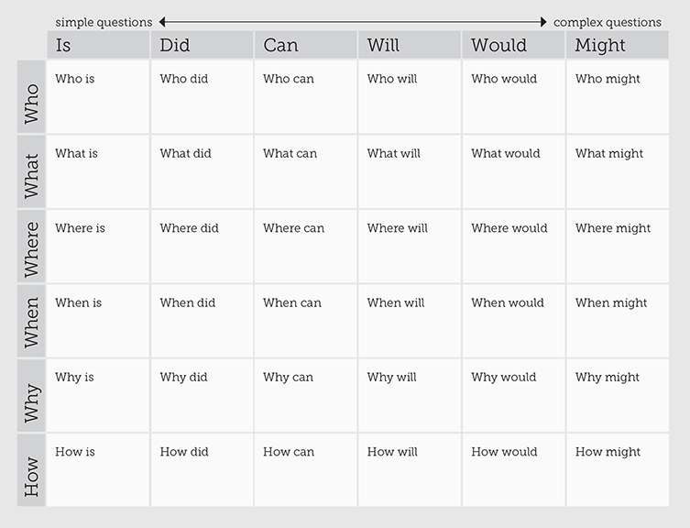

This article give examples of kids coming up with new ideas to solve problems.

This Hacktivity gives kids the opportunity to solve problems using prototyping with everyday equipment.

The d.school at Stanford University has done a lot of work around design thinking and these activities are ones you can easily try in class. The focus is on empathising with the end user:

5 Chairs Exercise
The Gift Giving Project
The Wallet Project

The City X Project gives a really nicely laid out scenario with different characters with design problems to solve. The focus is on 3D design with playdough, ultimately leading to using the 3D printer.

The book The Most Magnificent Thing by Ashley Spires reflects the ethos of design thinking really well. If you can’t get the book this is a link to a cute animation (with animation inspiration for kids too).
